PHYS 110 Workshop 3: Energy II

The big idea: | Applying the Investigative Process

The Physics in Everyday Life: An Interactions Approach supplemental textbook introduces the Investigative Process, a systematic method for describing, modeling, and analyzing complicated situations.

Make sure you’ve already read Chapter 1 and 2 of the Physics of Everyday Life book.

Imagine it’s your first day as a marketing intern for a design firm. They’ve assigned you to a group working on designing a flashy new roller coaster for a local theme park—and want you to dive into the process so you can sell the design in terms of its fun factor and its safety. In fact, “fun” and “safety” concerns with a physical system—that's very similar to what we did with the bungee jump in Chapter 2. You’ll be applying the same Investigative Process to this problem.

- Identify the Question
One of the designers shows you that the proposed roller coaster will have a cart that is launched from ground level, sending it up a tall hill. The hill is going to be as tall as possible given the city’s building code restraints. The team discusses the motion they expect the coaster cart to have as it is launched and goes up the hill:

C: Before the launch, it’s sitting still. Then after the launch, it’s moving really fast.
A: Does it keep getting faster the whole time? Or does it slow down after the launch, when it goes up the hill?
B: Or, it could stay the same speed, after the launch and up the hill.

There seem to be two different motions involved here: first, the launch of the cart and second, the cart moving up the hill.

Draw the motion diagram for the cart as it is launched. | Uniform Speed (Uniform distance between two successive balls)
Draw the motion diagram for the cart as it travels up the hill. | Decreasing velocity (decreasing distance between successive balls to show less distance for same time-period.)

The first question the designers want to solve is, “What speed should the cart be launched at?” However, in order to answer the question, the designers (and you!) have to consider many related questions as well:

  - What’s the acceptable range of launch speeds?
  - Should the cart just barely make it over the hill? How fast would the launch speed be to make that happen?
  - Should the cart go really fast over the hill? What’s the fastest it should go, and how does that change the launch speed?
  - Does the launch speed depend on other physical factors that could change the design of the roller coaster itself?
  - Does the launch speed depend on how steep the hill is?
  - Does the launch speed depend on how many passengers are in the cart?
Let’s address the first set of questions: what is the acceptable range of speeds? If the launch is too fast, it’ll be lots of fun (for the first moment), but might not be safe for a couple of reasons: there's a danger of the cart leaving the track at the top of the hill, and getting up to a very high speed in a short amount of time can have bad effects on the human body. However, if the cart launch is too slow, it’ll be safer, but not only less fun, it might not even make it over the hill at all! The ideal launch speed should be somewhere between the two extremes. Finding the values of those extremes would let us determine the range of reasonable launch speeds.
What about the second set of questions about other physical factors that might affect the speed? The shape or steepness of the track might matter—perhaps if it’s really steep, the initial launch needs to be faster...or maybe that’s true if the track is really long and shallow. Because this question is about the track, we’ll get insight into how it affects the speed by investigating the interaction of the cart with the track. We can also investigate how the presence of people affects the cart’s motion by looking at what happens with the mass of the cart is changed.

The first question you’ll investigate is: What launch speed would be the slowest possible, yet still allow the cart to make it to the top of the hill?
 | QUESTION 1: If only the launch speed itself matters, will you need to care about the part of the motion when the cart is launched, or the part of the motion when the cart is traveling up the hill? Justify your answer.  You need to consider the launching speed. This speed will sustain the motion of the roller coaster on the motion path as it approaches and climbs the hill. If the launch speed is low, then the rollercoaster might not even reach the base of the hill and if the launch speed is too high, then the roller coaster might dive off when it is high up in the trail. The minimum possible speed will be determined by the height h of the hill. The kinetic energy of the approaching roller coaster equals the potential energy needed by the roller coaster to reach the maximum height of the hill  1/2mv²=mgh

- Choose a Model
The first part of choosing a model is identifying the interactions.
Identify all of the objects that are interacting in the scenario of the cart traveling up the hill. | - Cart  - Trail  - Earth  - Air
List all of the interactions between all of the objects you identified. If the interaction is between objects A and B, list is as “A - B interaction”. | - Cart-Air interaction  - Trail-Earth Interaction  - Trail-Air Interaction  - Earth-Air Interaction

QUESTION 2: Which interactions can you ignore? Justify each with a physical reason or assumption.

Interactions between the roller coaster and other objects such as rollercoaster-rail, rollercoaster-air. In this case, the rollercoaster-air interaction is the only interaction that can be ignored since air is known to have minimal or no effects on systems. Besides, wind can cause movements on the rollercoaster but it is very unlikely to influence the setup since people only ride when the weather is conducive.

 | System | Environment
Determine which objects are in the system and which are in the environment. (You can use the usual guidelines you’ve seen in class for which objects are in the system) | - Cart  - Trail | - Air  - Earth (Hill)

- Applying the Model
 | Potential energy | Work
For each interaction you’re keeping in your model, identify if it corresponds to a potential energy or if it will do work. | - Earth-Cart Interaction | - Cart-Trail Interaction

Sketch the scenario identifying the the zero reference point and initial and final points of interest (we care about the car after it’s been launched, to when it just barely make it to the top of the hill at zero speed):
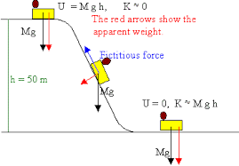

Draw the LOL diagram for the scenario. If you identified an interaction doing work, make sure to include it!
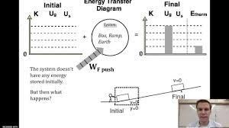

Write the energy model derived from the LOL diagram.
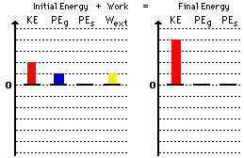

Solve your energy model for the variable we’re trying to determine (launch speed), as an equation:

$$\frac{1}{2}mv^{2}=mgh$$
V²=2gh
V=$\sqrt{2gh}$

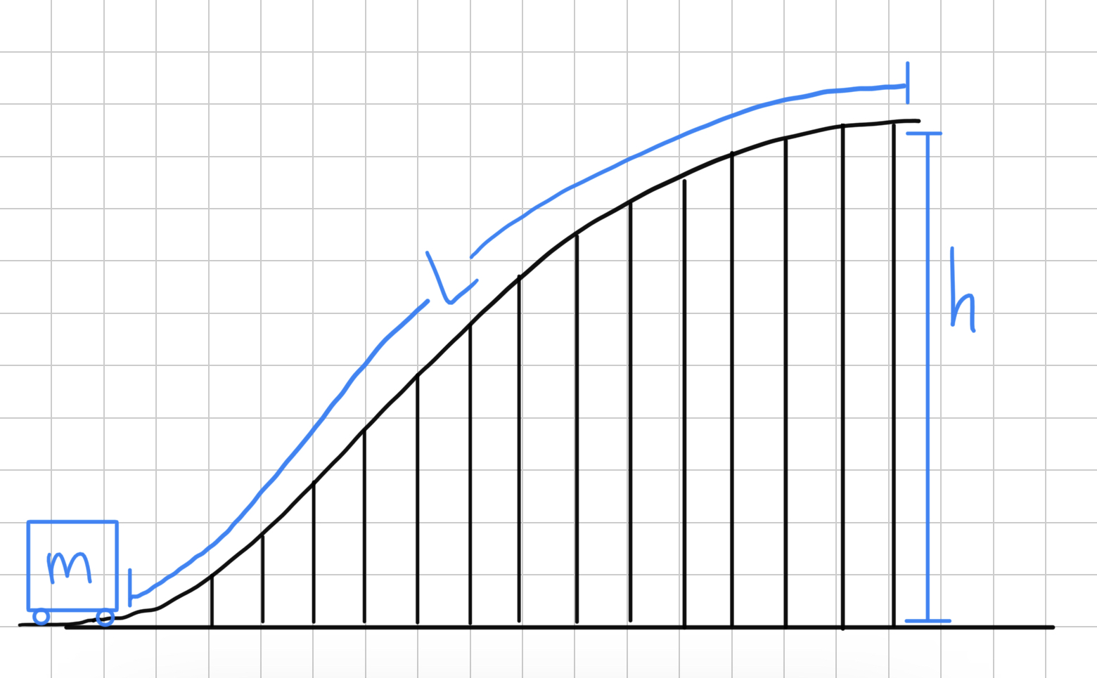
At this point you’ve gotten as far as you can without actual numbers. Let’s set up an example roller coaster track:

The designers have set the height h of the coaster’s first hill to 75 m, and the length L of the hill’s curved track is 180 m. The empty cart (without people) has a mass of 600 kg.
Additionally, the designers have determined that the empty cart feels a total resistive force of 60 N as it travels along the track, due to the interaction between the cart and the track, and interaction between the cart and the air.
Using any of these values that go into your energy model, determine the launch velocity of the cart that is the slowest possible speed and still have the cart reach the top of the hill:
H=75m, m=600kg
Since K.E = P.E
Then,
$$\frac{1}{2}mv^{2}=mgh$$
$$\frac{1}{2}×600×v^{2}=600×10×75$$
V=38.73m/s
=86.64mph

- Check the Model
First, let’s check the value of the velocity you determined.
QUESTION 3: Convert your result into miles per hour. A similar roller coaster with height 70 m has a maximum speed of 80 mph. Is your result realistic?

Yes. The air-track interaction does not play a big role in the motion of the roller coaster.

Now, let’s account for the effect of the resistive force acting on the cart. Is it necessary to be included, or can it be left out?
If you incorporated the resistive force in your original answer, use this space to find the velocity of the cart if there were no resistive force. You may want to make a new LOL diagram and energy model.
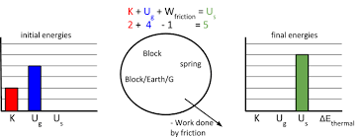
If you did not incorporate the resistive force in your original answer, use this space to find the velocity of the cart with the resistive force. You may want to make a new LOL diagram and energy model.

QUESTION 4: Is it justifiable to ignore the restive interactions between the cart with the track and air?
Find the percent difference between the two velocities. If there’s less than 10% difference between them, the resistive interactions can probably be ignored.
Yes.
$$\frac{86.64-80}{80}×100\%=8.3\%$$
Since the resistivity is less than 10%, then the resistive interaction between the air and the track can be ignored.

- Revisiting with a New Question: Maximum Speed
The minimum launch speed might be the safest, but it might be more fun if the cart is traveling faster.
Say the designers want the cart to travel at 25 m/s at the top of the hill. Now how fast must the launch velocity be?
Draw the LOL diagram for this new scenario. Incorporate the resistive interactions if needed (as justified above).
Write the corresponding energy model.
KE₁ + PE₁ + Work = KE₂ + PE₂

Solve the energy model for the launch speed, as an equation.
KE₁ + PE₁ + Work = KE₂ + PE₂
No mass of the cart.

The danger of the faster speed at launch comes, in part, from the higher acceleration needed.
If the launcher will take 1.1 s to take the cart from 0 m/s to the launch speed, determine the acceleration value for the slowest launch speed and this faster launch speed.

a=(v-u)/t
=(25-0)/1.1
=(22.73m/s²

QUESTION 5: Is the faster launch speed too dangerous? Accelerations greater than 40 m/s² can be dangerous to children.
Yes. Children may experience nausea and vomiting if the roller coaster moves very fast. Increased heartbeats and faster breathing may result in health problems.

- Revisiting with a New Question: Added Mass
A roller coaster that only takes empty carts up a hill is not very entertaining, however. How does the launch velocity change if the mass in the cart changes, as people sit in it?

Identify which situation you’ve determined already:
Does the resistive interaction need to be included? [YES/NO] | NO
Can the cart be fast at the top, or for safety reasons should you work with the slower speed (where it’s zero at the top of the hill)? [FAST/SLOW] | SLOW

For the situation you’ve determined, rewrite your energy model here, and show your result for the launch velocity as an equation.

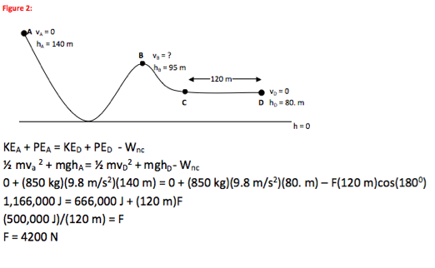

The cart can fit 8 people. Assume that all eight are adults, with an average mass of 80 kg.
Using the values given, determine the launch velocity needed for the heavier cart.
1/2X800v²+0=o+8000X10X70-8X80X10
V = 37.40m/s

QUESTION 6: Is this result surprising? Describe some practical effects of this result—how would the roller coaster launch have to change to take into account the higher mass, or would it not have to change anything?

Huge accelerations result in to increase in velocities. When the roller coaster reaches the critical velocity, the machines may not be able to hold the cart in position and this may cause terrific accidents. An increase in mass increases the kinetic energy, therefore, to maintain the motion of the roller coaster at a normal climbing rate, then the launch velocity will have to be reduced in the same proportion as the increase in mass.

